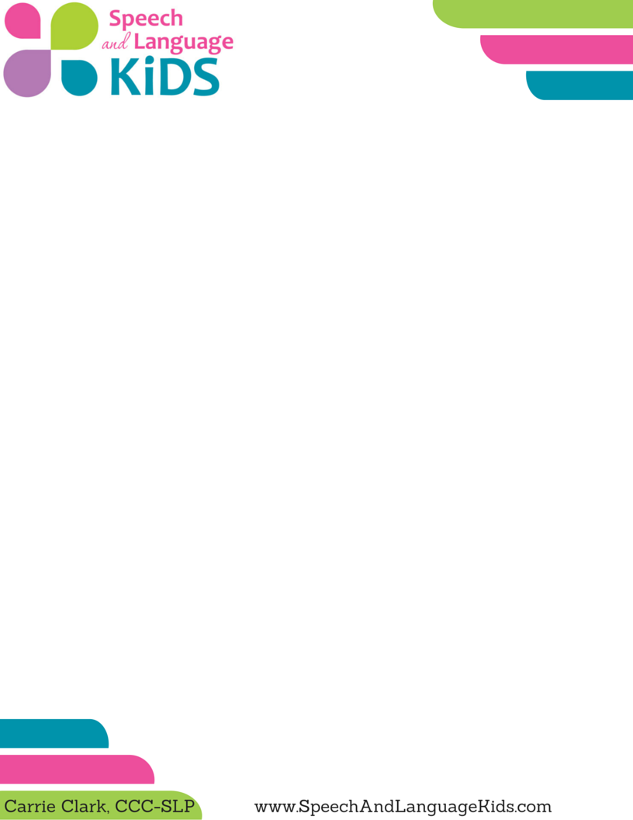

**Social Story: Throwing for Sensory Input**

**Introduction:** Many young children throw things. Children engage in behaviors for one of five reasons: escape, avoidance, to get something, to get attention, and for sensory input. If you are working with a child who seems to be throwing things just because he loves the feeling of throwing (sensory input), it can be helpful to give the child a safe place to throw and teach him not to throw in other   
locations.

**Instructions:**

1) Edit this story to fit the student that you are working with. If the child has lower language skills, use simpler language. If the child is using throwing in a situation other than those listed, insert a different situation that you want to make sure the child knows not to throw in. You can even add pictures of the child instead of using these of my child.

2) Print the pages and cut them in half along the line. Laminate if you’d like it to be more durable. Bind them in some way, even if it’s just a hole punch with a string tied through.

3) Set up a throwing station for the child that is a safe place for the child to throw. I have added targets to ours by taping string to disposable cups and hanging them from the wall.

4) Read the book with the child. Show the child the safe place to throw that you’ve set up. Read the book again. Read the book often!

5) When you see the child throwing at a place that is not the throwing station, say “I see that you need to throw something. You can throw at the throwing station” and walk him over to that area to throw.

**Additional Tips:**

If the child tends to throw during the same situation each day, try to plan some heavy work right before that activity occurs. Heavy work is anything that gets the child to use his muscles with maximum effort. Think about heavy work that involves the muscles of the arms, such as carrying something heavy down the hall, doing wheelbarrows (where you hold his feet and he walks on his hands), or doing push-ups.

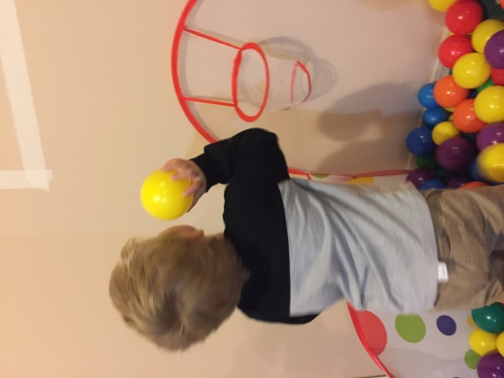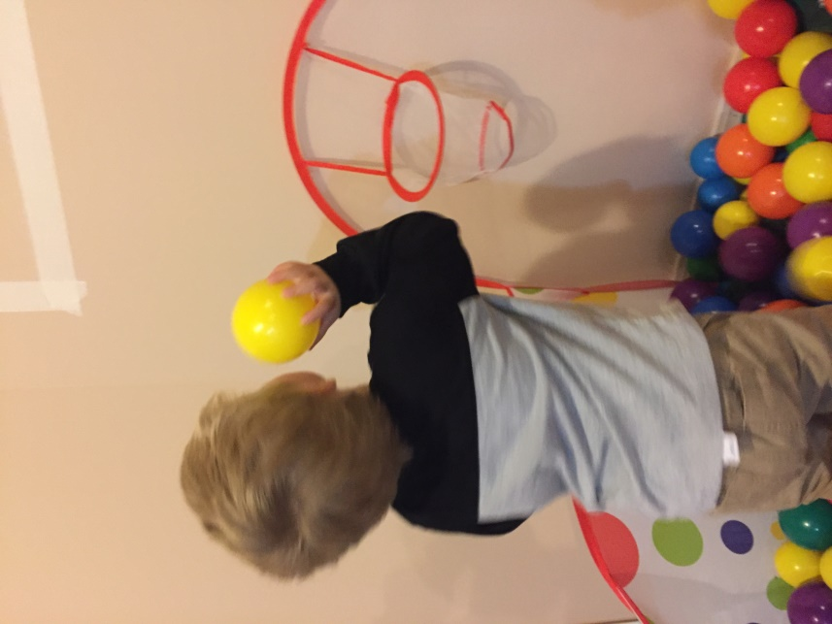

I Love to Throw

By: _____________

My name is ______ and I like to throw.

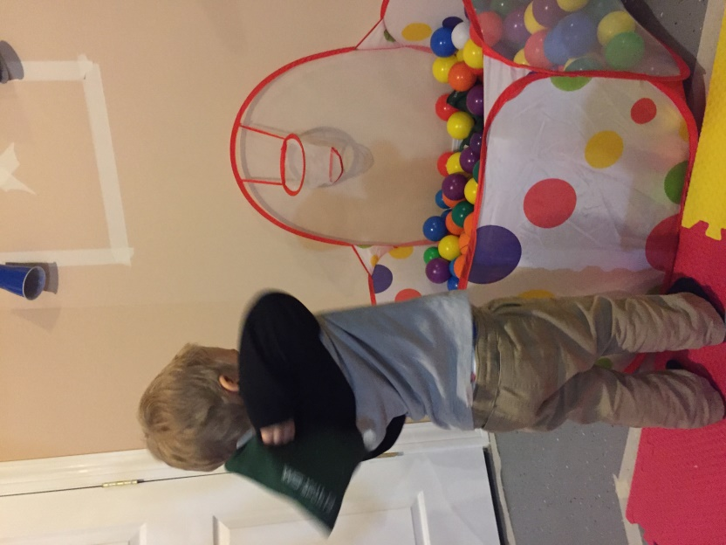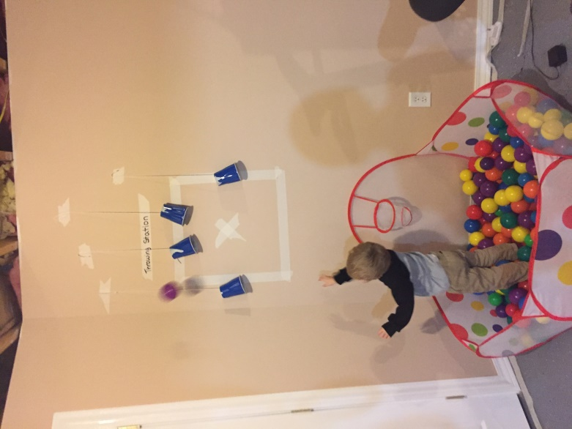

I only throw balls and beanbags.

I only throw when I am outside or at the throwing station.

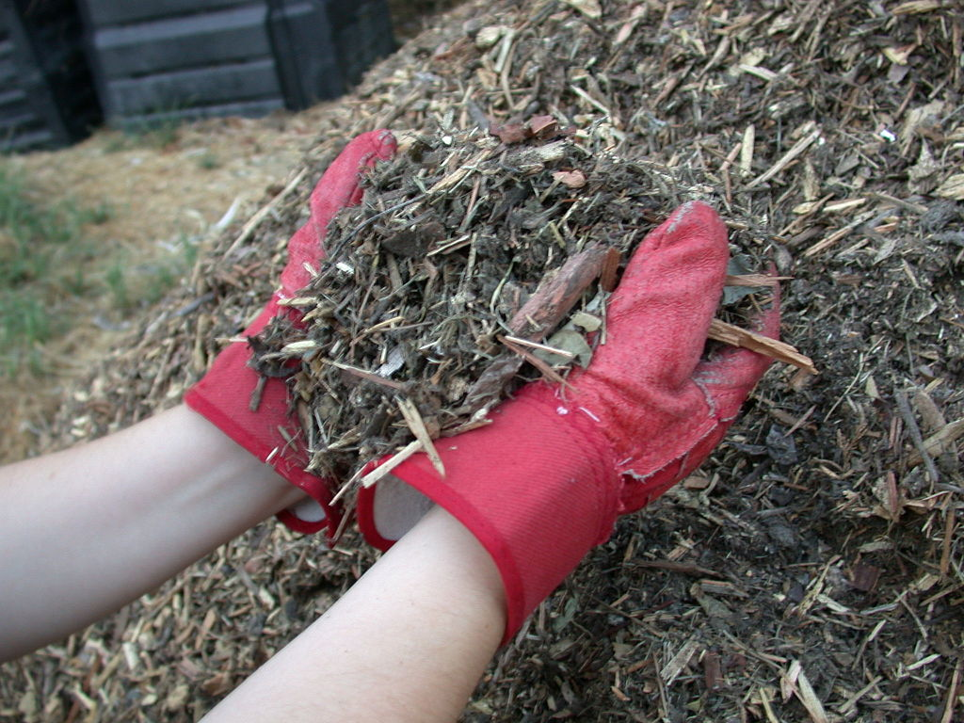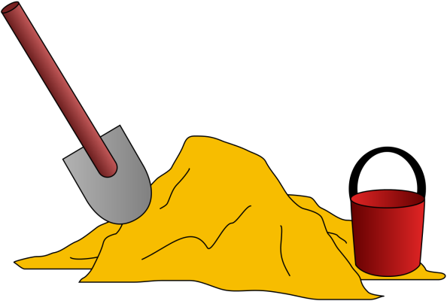

Do I throw mulch? Goodness no!

Mulch might hurt my friends.

I only throw balls and beanbags.

Do I throw sand? Goodness no!

Sand could get in someone’s eyes and hurt.

I only throw balls and beanbags.

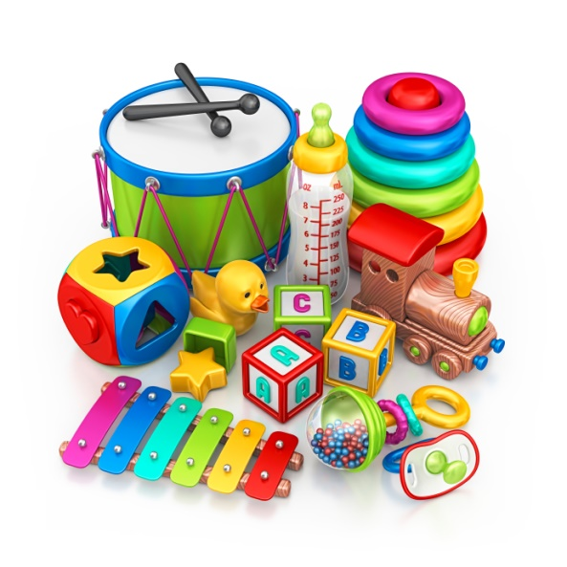

When I am inside and feel like throwing, I can go to the throwing station.

Do I throw toys? Goodness no!

If I throw toys, I might break something or hurt someone.

I only throw balls and beanbags.



I only throw balls and beanbags at the throwing station.