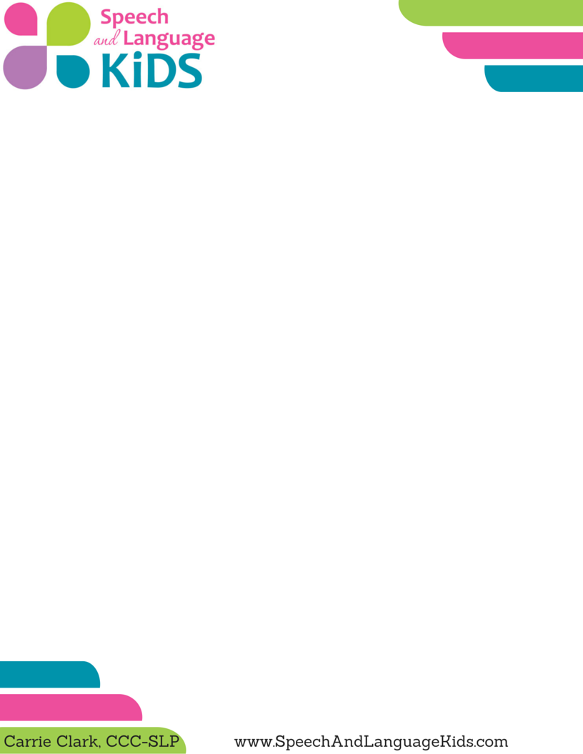

**Social Story: How to Initiate with Friends (for Verbal Children)**

**Introduction:** It can be difficult for children to know the right words to use to initiate interactions with peers. Sometimes, children may resort to hitting or pushing as a way to initiate an interaction if they don’t know the proper words to use. This social story can be used to teach a verbal child (one who is already speaking) the correct words to use to initiate an interaction with a peer.

**Instructions:**

1) Edit this story to fit the student that you are working with. If the child has lower language skills, use simpler language. If the child typically tries to initiate in a different situation than the ones listed, you can add more scenarios. You can even add pictures of the child instead of using these of my child.

2) Print the pages and cut them in half along the line. Laminate if you’d like it to be more durable. Bind them in some way, even if it’s just a hole punch with a string tied through.

3) Read the book with the child. Talk about the different types of situations where the child may want to ask a friend to play.

4) Role play these scenarios with the child. Make sure the child gets to practice saying the actual words.

5) Read the book again right before a child is going into a situation where other children will be playing. Prep the child ahead of time for what to say.

6) At first, watch the child during these interactions and remind him of words he can say when he seems to be struggling with how to initiate interactions. When I do that, it sounds like this: “Johnny, you can say ‘may I play with you?’”.

7) Fade back the amount of prompting that the child needs. Try to remind him less and less and let him take over his own interactions.

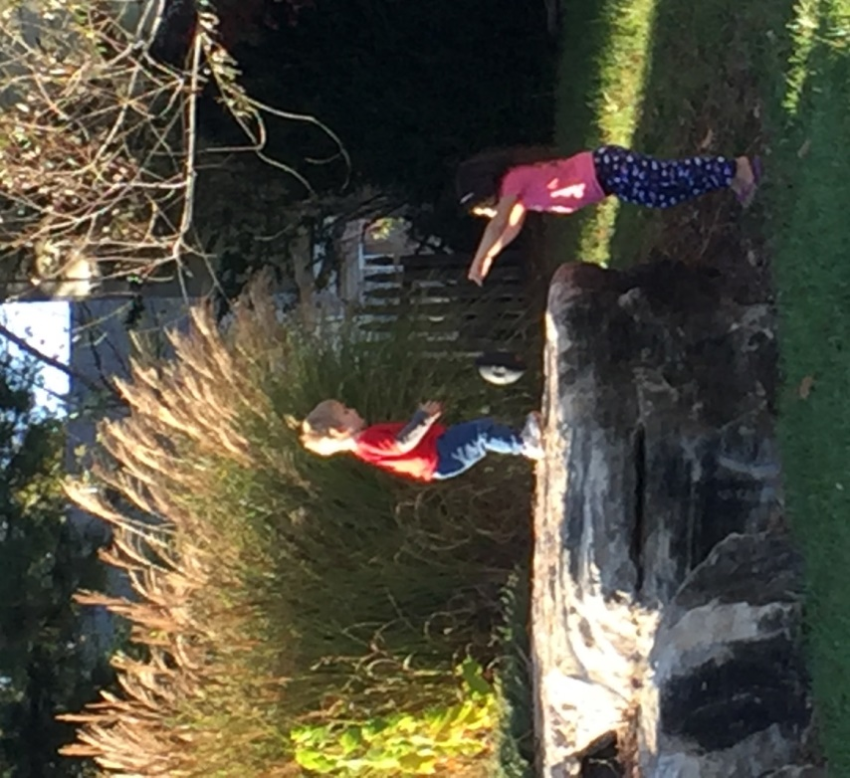

I Play with Friends

My name is _________ and I like to play with my friends.



When I want to play with a friend, I use my words.

I can ask my friend to play.

When I ask a friend to play, I get close to my friend.

I talk with a loud voice so my friend can hear me.

Hi!

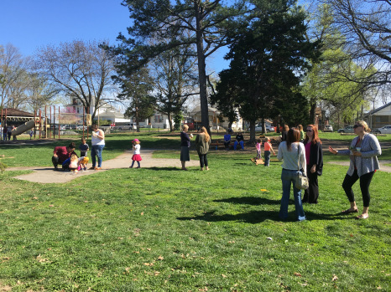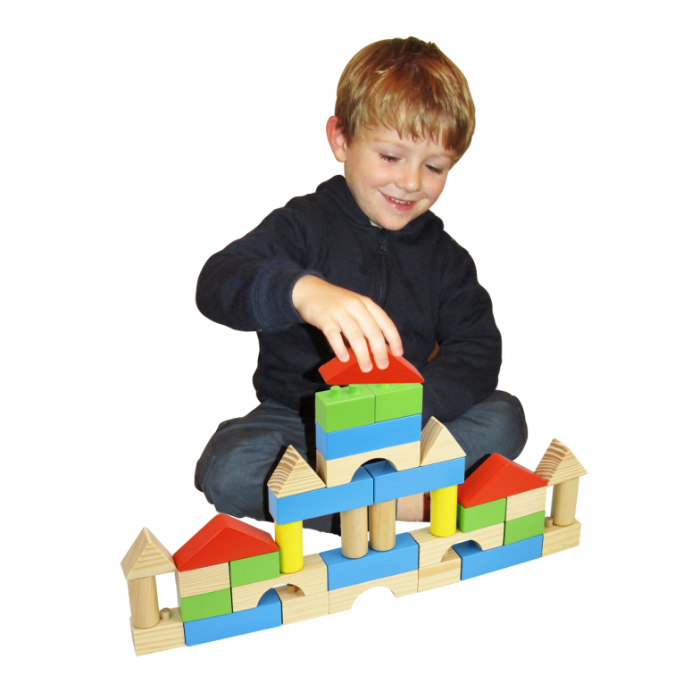

When I see a friend playing outside, I can say,

“Do you want to play with me?”

If my friend is playing with blocks, I can say,

“Hey, that’s cool! Can I play with you?”

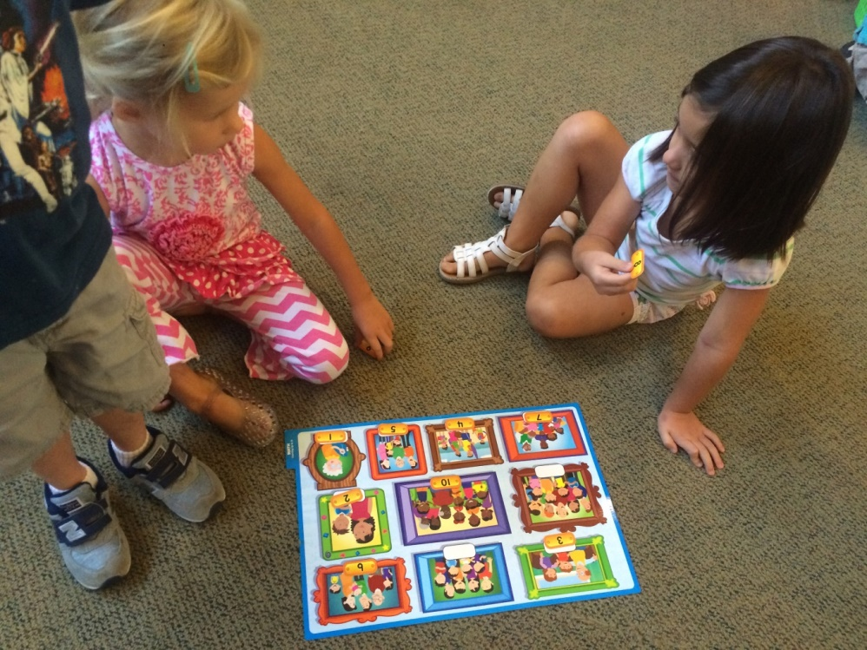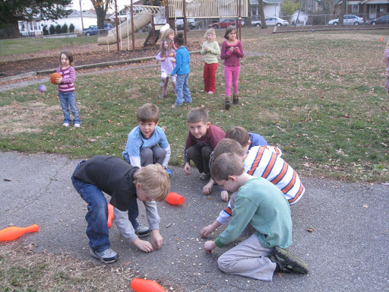

If I want to play a game with someone,

I can pick up the game and walk over to my friend.

Then, I can walk over to my friend and say,

“Hey, do you want to play this with me?”

If I see that my friends are already playing something, I can say,

“What are you guys doing? Can I play?”

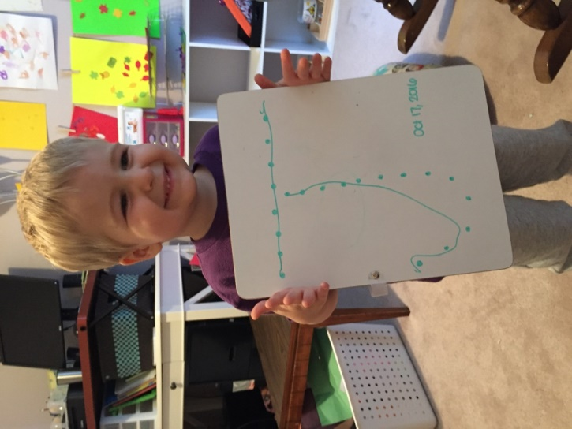

If I want to show my friend something, I can say,

“Hey, look at this!”

If I want to know what my friend is working on, I can say,

“Wow, what’s that?”